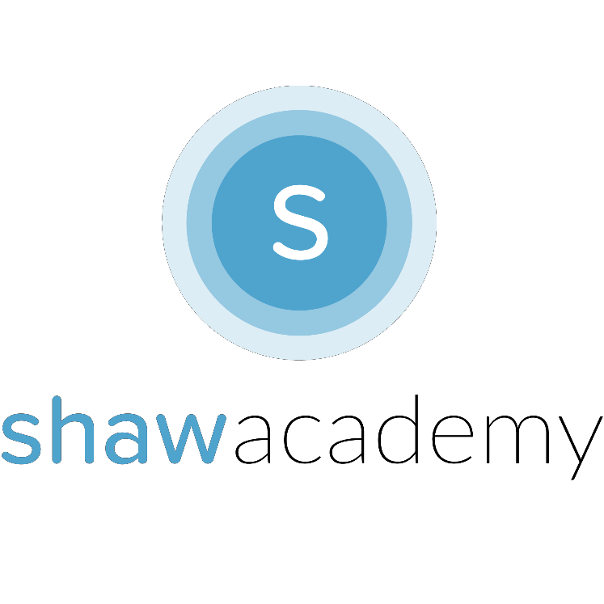
Storing Persistent Data
A Database is used to Store Data about the App even after the App has been closed. It is known as a collection of related data that can be organized.

Persistent Data is information that is infrequently accessed – such as Username, Password, Preferences, Images or Files – that are unlikely to be modified or changed. Data that we would like to keep even after the End-User has shut off the mobile device.

Local Storage This is a Database that can be stored locally on the Machine without needing to be backed-up to a Server online. In App Inventor, we are able to use TinyDB to store values like a Login Password or Search Term to store a User’s Personal Information Securely.

TinyDB uses a Tag/Value Pairing System to store the information locally on the device. There is no inherent limit of the number of tags the TinyDB can store, only space limitations involved are whether your device has sufficient storage.

There is also a TinyWebDB that can be used for interacting with a Test Server to make your App available online. This Test Server is great during Development & Debugging Stages for your App however, upon publishing your app, you will need to update this Test Server to your own Server for Storing User Information Securely such as SQLite or a Content Provider.
Project Sample from App Inventor 2
To get the most from any programming language, the best thing to do is practice. The following examples will get you up and running with a Database in your App:

A Personal Assistant App:

This App uses speech-to-text API to Record your Thoughts. It can only be accessed through a password-protected screen.

Screen 1 Properties

BackgroundImage: yourLogo.png

Icon: yourIcon.png

Title: My PA App

Components for Screen 1:

TextBox | PasswordInput | BackgroundColor: FontSize:  TextColor: | Cyan  20  Blue
Button | SubmitBtn | Width: Hint:  BackgroundColor: | 100 pixels  Password  Blue
 |  | FontSize: Shape:  Text: | 14  Rounded  Submit

Screen 2 Properties
BackgroundColor: Cyan
Title: ThoughtsScreen
Components for Screen 2
Button ThoughtsBtn BackgroundColor: Blue
FontSize: 20
Text: “Talk to Me”
Label ThoughtDesc FontSize: 14
Text:“-Your Thoughts Here-”
Speech-Recognizer

TinyDB

Adding Functionality:

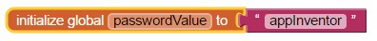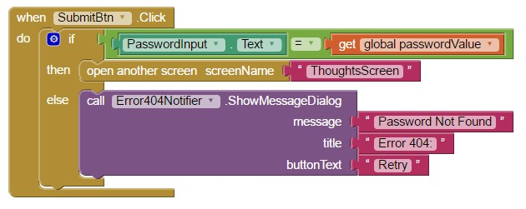Step 1: Create the Password: Step 2: Check the Password:

Next Open the SecondScreen in your App to Record your Input.
Step 3: Record your Thoughts:

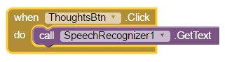

Step 4: Convert Speech to Text & Store the Data:

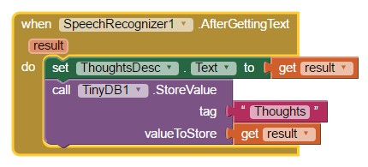

Step 5: Set Up the Database for First Use:

